**Brooklyn torah gazette**

**For parshas vayikra 5780**

Volume 4, Issue 29 (Whole Number 181) 3 Nissan 5780/ March 28, 2020

**Printed L’illuy nishmas Nechama bas R’ Noach, a”h**

**Helping the Jews in Uzbekistan and Georgia**

**By Rabbi Sholom DovBer Avtzon**

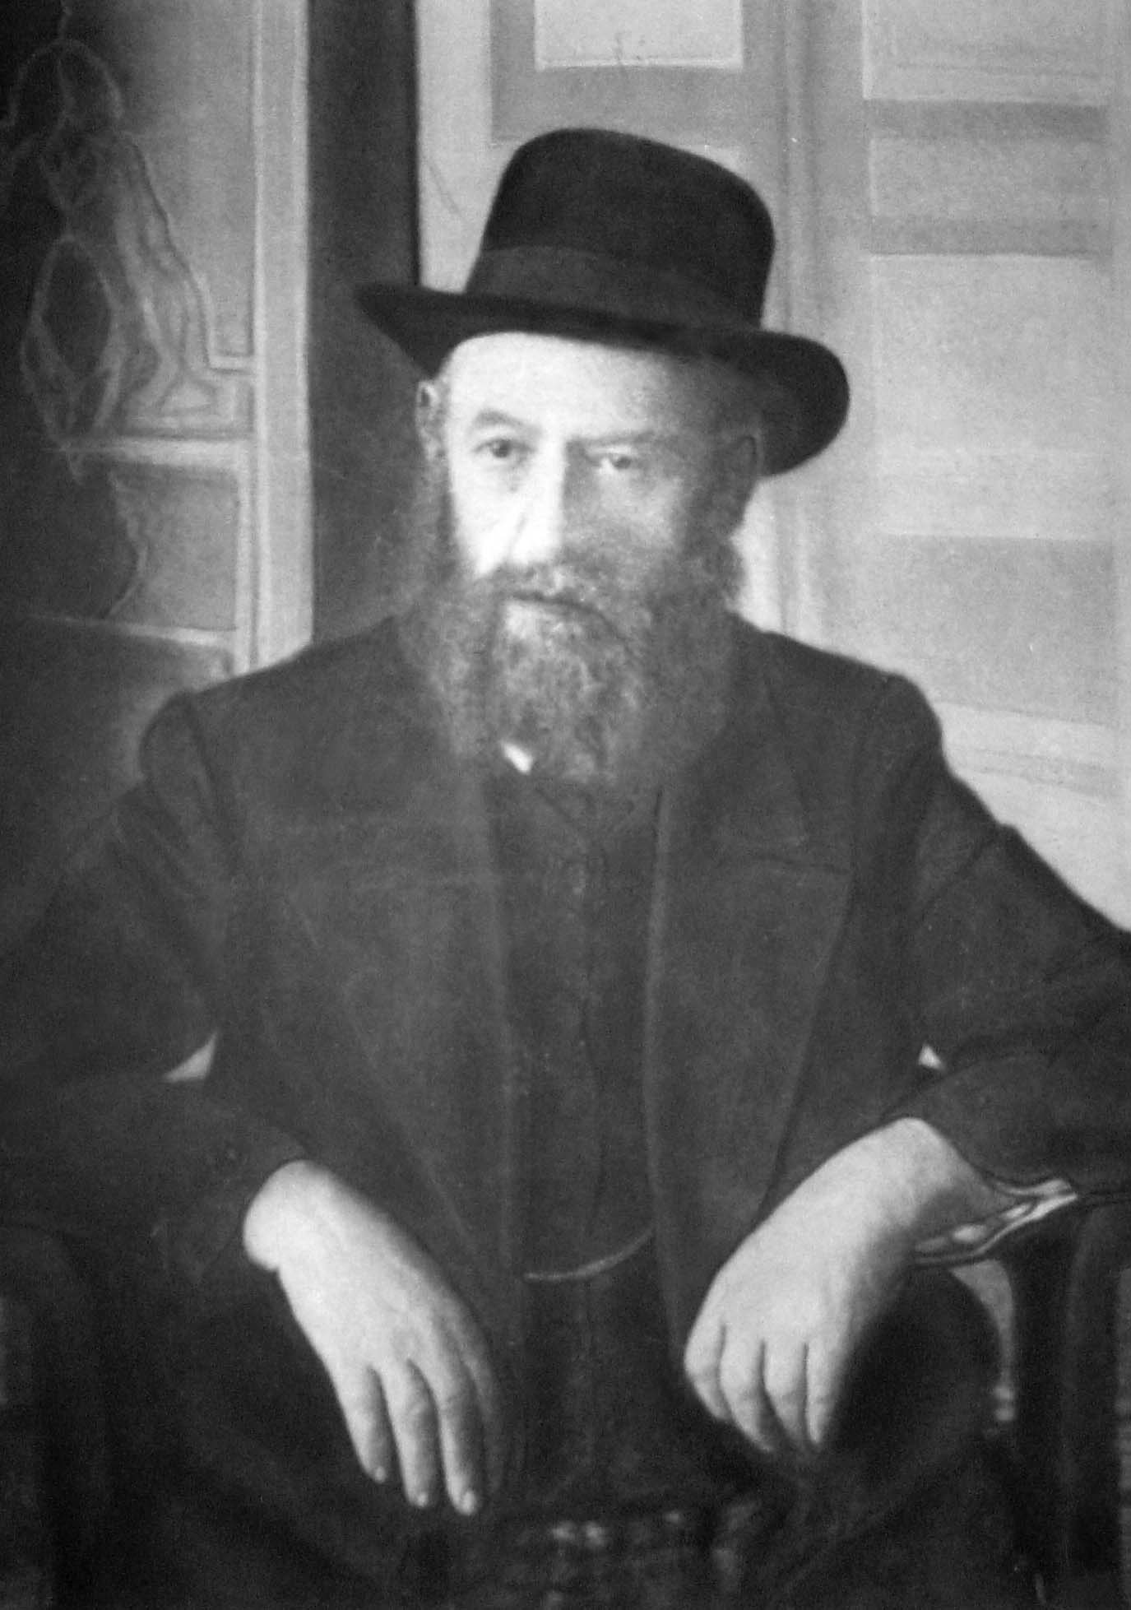

When the Rebbe Rashab (Rabbi Sholom DovBer Schneersohn of Lubavitch,, 1860-1920) traveled, he observed and took an interest in the material and spiritual well-being of the Jews in the countries he visited. We don’t know how involved he became in the welfare of those communities, but from his activities in the Sephardic communities of Uzbekistan and Georgia (Gruzia), we can see that the purpose of his interest wasn’t just to find out information, but to see if there was any way he could help them. To him, the welfare of every Jew was important, no matter whether he was *chassidish* or *litvish*, Ashkenaz or Sephardic.

In 5652 (1892), Reb Shlomo Yehuda Leib Eliezerov,[1] who was the Rov in Chevron, was sent abroad by the local Sephardic community to raise money for the Jewish community of Chevron. One of the areas he visited was Georgia (at that time in the southwestern part of the Russian Empire), and when he was there, he informed the Rebbe Rashab about his visit. In his reply, the Rebbe asked him to evaluate the (material and) spiritual situation there and see what could be done to improve it.[2] Indeed, Reb Shlomo Yehuda Leib gave the Rebbe a detailed report.

Five years later, in 5657 (1897), he traveled once again on a fundraising mission for the Chevron community, this time going to Uzbekistan (then known as Buchara, at that time an area in Russia further east). Seeing the lack of education there, he realized that a *cheder* and yeshiva needed to be established. After corresponding with the Rebbe, he decided to remain there and do this himself. However, understanding that the Jewish community might be skeptical of his involvement, as he was an Ashkenazi and they were Sephardim, he turned to the *Rishon L’Tzion* (Sephardic chief rabbi) in Yerushalayim, HaRav Yaakov Shaul Elyashar, for assistance.

It happened to be that there was no Rov in Uzbekistan at the time, so the *Rishon L’Tzion* appointed him as the Rov, on condition that he would rule in accordance with the rulings of the *Beis Yosef*.[3]

Reb Shlomo Yehuda Leib accepted the position for three years. In addition to establishing a *cheder* and yeshiva in the cities of Samarkand and Tashkent, he raised the level of *shechitah*, making sure the *shochtim* didn’t just know how to sharpen a knife properly and *shecht* but were also well-versed in the *halochos*.

Satisfied that everything was now in order, when the three years were over he returned to Chevron. But then, three years later, in 5663 (1903), he came to Uzbekistan again to raise funds, and the community convinced him to stay with them for a short while.

Then, in 5666 (1906), the Rebbe Rashab suggested that he return there once again. Reb Shlomo Yehuda Leib pleaded with the Rebbe not to send him there again for a third time. However, the Rebbe replied that it was imperative for him to go, so he remained there for another year.

In 5670 (1910), he came back to Russia from Chevron and stayed in Lubavitch for an extended period of time. Knowing that the community in Samarkand needed a Rov, he asked his nephew, Reb Avrohom Chaim Naeh,[4] to take his position for two years. Afterwards, in 5674 (1914), Reb Shlomo Yehuda Leib returned to Samarkand, as Turkey expelled all Russian citizens from *Eretz Yisroel* during WWI. He remained there until 5682 (1922), a few years after the Communist takeover, when he returned to Chevron.

While Reb Shlomo Yehuda Leib was taking care of the Bucharian Jews, the Rebbe also focused on the Jews of Georgia. In 5672 (1912), he sent the chossid Reb Schneur Zalman Altschuler to become the *shochet* there.

Four years later, shortly after the Rebbe settled in Rostov, a delegation of Jews from (the Republic of) Georgia[5] traveled to meet with him.[6] They requested from the Rebbe to send a Rov who would help elevate the spiritual level of their community. The Rebbe responded[7] that he would do so, and he wrote a letter to their *chacham* (Sephardic spiritual leader) confirming this.[8] A short time later, the Rebbe asked Reb Shmuel Levitin, who was then the Rov in Rakshik, Lithuania, to go there and strengthen the spiritual level of the community through opening a yeshiva and other activities.

Many of Reb Shmuel’s friends were surprised at this development. They wondered how it was possible for the Sephardic community in Georgia to accept an Ashkenazi Rov who didn’t speak their language, and they advised him to take a more prestigious position in Russia itself. To them, this was something completely out of the ordinary.

Besides for opening a yeshiva in *Eretz Yisroel*,[9] where there were many chassidim, the Rebbe had never sent someone to live in another country, with a different language and culture, to open a yeshiva there.[10]

However, Reb Shmuel responded that he was happy to go where the Rebbe wanted, and he would do it joyfully, not merely out of obedience.

Reb Shmuel arrived in Kutaisi (one of the main cities in Georgia) before Pesach of 5676 (1916), and he was warmly welcomed by the chief *chacham*.[11] Seeing the honor their venerable leader was giving him, all the Jews there accepted him, and he immediately set out to establish a yeshiva.

The Rebbe wanted to make sure that Reb Shmuel would not be stymied in his efforts due to financial difficulties, so he personally made sure to cover the expenses needed for his family. He also helped him out with the additional expenses of establishing a yeshiva and his other activities.

As the yeshiva expanded, the Rebbe sent some *bochurim* and additional married couples to help out Reb Shmuel. [One of the first chassidim] to be sent were Reb Leizer Karasik and. Later on he also sent additional Rabbonim, and they each opened a yeshiva in another city.

Their success was phenomenal. The original students learned quickly, and they became the teachers for their neighbors’ children. No longer was it necessary to have someone translate what the rabbi or teacher was saying, as these new teachers spoke in their native language. The local Jews saw that the chassidim were not trying to take over the community. Rather, they wanted to raise the leaders of the next generation from the children of the community, and this solidified their respect.

In the short span of just a few years, over one thousand boys learned in the various yeshivos. Reb Shmuel’s yeshiva was in the largest community (Kutaisi) and had four hundred students.

This transformed the entire community. As the students became knowledgeable in *halachah*, they politely informed their parents that certain details in *kashrus* and other areas needed to be enhanced. Some of these students were taught the laws of *shechitah* and became the *shochtim* of the region.

When Uzbekistan and Georgia came under Communist control, for the first few years they did not wage war against religion there as they did in Russia proper, and the community’s activities continued openly until the mid-1920s. Then, Jewish activity was forced to go underground there as well.

*Reprinted from the Parshas Vayakhel-Pekudei 5780 email of Rabbi Avtzon’s Weekly Story. Rabbi Avtzon is a veteran mechanech and the author of numerous books on the Chabad Rebbeim and their chassidim. He can be contacted at avtzonbooks@gmail.com*

**Rav Avigdor Miller**

**On Don’t Be a Shlep**



**QUESTION:** Does striving to become successful and comfortable take away from achieving Torah and *yiras shomayim?*

**ANSWER:** Now we come to a subject that has to be explained. I'm going to take a minute to explain that. How foolish are people who don’t understand how to fit in *olam hazeh* with *ruchniyus*, with spiritual things.

In order to succeed as a decent Jew, you have to have a decent *gashmiyus —* a Jew must have a profession, he must have a calling. Now, that doesn't mean you have to be a doctor of medicine, but you have to have some way of making a living. And just to be a *shlep,* just to be a failure, that's no way to succeed as a Jew.

Now, if you're a man who can succeed in learning – if you’re capable of learning all day long – so there'll be some people who will support you; there are *kollelim*, there are places where you can go.

But most people don't do that. So you must live a normal life and you must learn a trade, you must learn some calling. And you have to have a home and you must have a wife. You must earn your own way — you cannot live on welfare; anybody who lives on welfare is a flop, a failure, and his life is ruined too; even his *ruchniyus* is ruined.

And so let's not deceive ourselves; the *Gemara* says that a man must teach his son an *umnus:* ראה חיים עם אשה אשר אהבת — *See life with a woman who you love.* So the *Gemara* says, what does it mean with a woman who you love? It means the Torah – the Torah is the woman you love; the Jewish nation loves the Torah. But it says that you must “see life with the Torah.” It means learn an *umnus;* that’s what the *gemara* says. You need to learn some kind of livelihood.

Again and again we've seen tragedies of people who neglected to learn a livelihood. There's a man in Crown Heights whose wife is an idealist — she's a *giyoress*, a *ger* *tzeddek*, a big idealist. And she tells me she met this Jewish young man; she made him *frum. S*he loves him, she tells me.

So I asked her, “What’s he doing?

“He's a writer,” she tells me.

“Has he published something?”

“No.”

“What does he do?”

“He lies in bed all day long.”

I said, “A man like that – why doesn't he do something?”

“Oh,” she says. “He's a great idealist, he's thinking up plans; he's drawing up plans for some great work.”

Well, a little time passed by and the next I heard she had left home with three little children, because he was beating her up – this “great idealist” was beating her. And that's the wreck of an idealistic marriage — a *giyoress tzeddek*, a righteous convert, and she was an idealist, and she was beaten up by this bum, by this writer, because he never learnt a *parnasa*.

There's a lot of people like that, ruined people. You can't live in a cellar; you have to live in a decent home. Only that I must put in a word of warning – you shouldn't put in all your efforts into beautifying your home; but still you must have a fitting frame for the right kind of a picture. You must make a living. You must guard your health. You can’t neglect your health and just be a *shlepper* who is run down in health. You need fresh air, you need exercise, you need the right diet.

Now, this is the subject that deserves a lecture by itself; I don't have time for it now. I just want to sum up: in order to live a decent Torah life, you must have a proper and decent material life – the two go together. And that's the *ratzon Hashem* and it can be proven by many statements in the Torah.

*Reprinted from the March, 2020 of Toras Avigdor adapted from Tape #308.*

**Parshas Vayikrah**

**Things I Do and**

**Things I Don’t Do**

**By Rabbi Bentzion Shafier**

**Founder of TheSmuz.com**

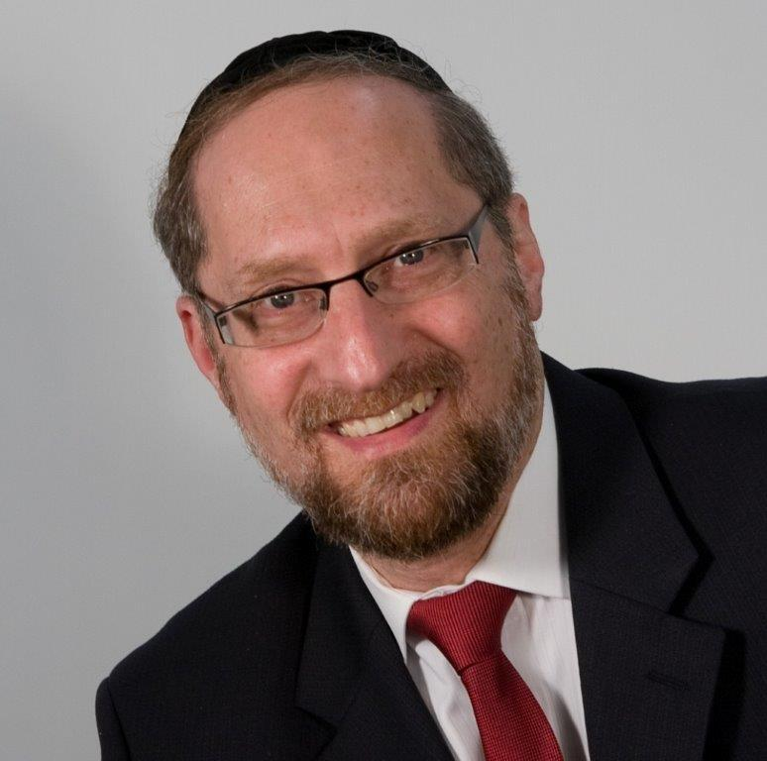

“*You shall salt your every meal-offering with salt; you may not discontinue the salt of your G-d’s covenant from upon your meal-offering — on all your offerings shall you offer salt*.” — Vayikrah 2:13

The Da’as Zekeinim explains that the reason every korban must be brought with salt is to remind us that just as salt is a preservative that allows food to last longer, so too the sacrifices are permanently ours to cleanse us from our sins.

He then explains why this concept is crucial. If a man sins and gains atonement from that sin, he is clean and will then be guarded against committing the sin again. However, if he couldn’t become purified, once he sinned, he would repeat the act over and over again.

It can be compared to a man with a beautiful white garment. When he first puts it on, he is careful to maintain its pristine condition. Once his garment becomes soiled, however, he is no longer careful about avoiding additional stains. So, too, if a man sinned and that sin remained with him, he will continue committing that sin over and over again. This is the concept that, “Once a man sins, the sin becomes ‘permitted’ to him.” That is why the Torah gave us the process of teshuvah.

**The Sin is Permitted**

This Da’as Zekeinim seems to be mixing up two divergent concepts. The first is “na’aseis lo keheter” — once a man sins, the act becomes “permitted.” We commonly refer to this as rationalization: the ability to distort reality and actually believe it, the uncanny capacity to take something that is forbidden and with a flow of imagination create a credible, “rational lie” that is good enough for me to convince myself that the act is really not taboo.

But this has no connection to the parable of a man with a clean garment. That is a natural tendency. If my garment is clean, then I will be guarded about maintaining its beauty. If it is soiled, I will not be as careful. What connection does that have to rationalization?

Rationalization is a completely different concept. It takes a sin and washes it in a coat of white paint so that in my mind’s eye, the forbidden becomes permitted. If the sin becomes permitted, then even if my cloak were cleaned from the sin, I would still revisit it since it is, after all, permitted.

The answer to this question is based on a deeper understanding of rationalization.

One of the most difficult parts in all of Creation is how HASHEM fashioned man with free will. Free will means the equal ability to choose good or evil. That should be impossible. How do you take man, whose wisdom is greater than the malachim (angels), and give him free will? Since every mitzvah allows him to grow and every sin damages him, not only should man never sin, he should never even be tempted to sin. Would an intelligent being willfully do something that is self-destructive?

To allow for free will, HASHEM implanted into the human a power called imagination. This power allows man to create fanciful scenes and imaginative events and experience them as if they were real. It allows man to convince himself of whatever he wishes. As a result, there is no objective truth. There is no standard of measure because man at his whim can create entire theories and systems of logic to justify what he wants — and actually believe them.

Now, man can just as easily do what is right as what is wrong… because he can convince himself that it is right. If he desires something, it is no longer a sin. It is no longer damaging to his soul. In fact, it is a mitzvah. Now, man has practical free will.

This mechanism is the common form of rationalization — taking a forbidden action and making it permitted. But it seems that the Da’as Zekeinim is teaching us that there is yet another method, one that is far subtler.

This second form only begins after the sin, after I find myself having done something that I never thought I would. I wake up and say, “What came over me?” And then starts the guilt — that voice inside, my holy neshamah, gnawing deep within me. And it speaks: “How could you? What’s wrong with you? I’m ashamed of you.”

Living with that guilt is very difficult. The easy way out is to make the act permitted — but I’m too smart for that. I know it’s forbidden. If you were to ask me about it, I could quote you chapter and verse what’s wrong with it and how wrong it is. So now what?

That’s when the second form of rationalization kicks in: “Look, I’m not saying it’s permitted. I’m certainly not saying it’s a mitzvah — but it’s just one of those things that I do. Some Jews wait three hours after meat, some put on their tefillin sitting down, and I eat non-kosher gum. I’m not saying it’s right, but I do it. But I’m not living in a fantasy world. I know that it’s a sin, but for me, for where I’m coming from, after what I’ve been through — it’s well… you have to understand… it’s okay.”

And this is the second form of rationalization, where what I create is this fanciful state: that for people like me, in my situation, it’s understandable; it’s okay.

**The Process of Teshuvah**

The Torah gave us the process of teshuvah to allow us to change. By getting rid of the sin, I become cleansed. My cloak becomes clean and white again, and the act returns to the realm of something that I don’t do. I never would — it would dirty me, it would sully me, and it’s not the kind of thing that I do. Now I can properly separate myself from the sin and put it back into the category of things that a person like me just doesn’t do.

This concept is very significant because the most difficult challenge we humans face is change. Growth requires a huge amount of effort, willpower, and motivation. However, it also requires much wisdom. Only when a person understands the inner workings of his own psyche and the subtlety of how his mind functions can he take on the gargantuan task of self-mastery.

*Reprinted from this week’s website on TheShmuz.com This is an excerpt from the*[*Shmuz on the Parsha book*](https://theshmuz.com/product/shmuz-on-the-parsha-book/)*.*

**The Significance of the**

**Poor Man’s Meal Offering**

**From the Talks of the Lubavitcher Rebbe**

**Rabbi Menachem Mendel Schneerson, Zt”l**

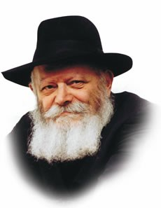

With this week's Torah reading, Vayikra, we begin the Book of Leviticus, which contains a detailed account of the various offerings brought to the Sanctuary and the Holy Temples.

Though the physical Holy Temple in Jerusalem was destroyed almost 2,000 years ago, the Torah's teachings are eternal, and apply always.

Furthermore, as we stand now on the threshold of the Messianic Era, the laws of these offerings will be in effect very soon in the Third Holy Temple.

One of the offerings discussed in our Torah portion is the Mincha, or meal-offering, about which the Torah says: "When any soul will bring a meal-offering to the L-rd; his offering shall be of fine flour, and he shall pour oil upon it, and put frankincense upon it."

What are we to learn from the Torah's use of the word "soul," something it does not do in connection with any other voluntary offering?

Our answer lies in an examination of the Mincha itself.

As Rashi, the great Torah commentator explains, a meal-offering is usually brought by a poor person, who cannot afford to sacrifice an ox or even a lamb.

G-d's choice of the word "soul," therefore, recognizes the great loss the relatively inexpensive meal-offering represents to the impoverished person: to G-d, it is as if he offered up his very soul.

When a wealthy man parts with one of his flock, it makes little difference to his overall financial situation. The poor man, however, needs to invest much labor to be able to purchase the flour and oil that make up the Mincha. His offering represents true personal sacrifice, and more of a willingness to draw closer to G-d -- the purpose of all the sacrifices that were brought on the altar.

The poor man has many needs; most certainly the money could have been used to ease his plight. Consequently, the meal-offering represents the poor man's triumph against his evil inclination (which no doubt encouraged him to use the money for selfish means), and is therefore especially beloved by G-d.

Even now, during the exile, we can perform this same mitzva, albeit in the spiritual sense.

We find an allusion to this in the verse, "If any one of you brings an offering": If a Jew truly wants to draw nearer to G-d, it must come "of you" -- from deep within. The Jew must sacrifice his "animal soul" -- his evil inclination -- for the sake of attaining this closeness to G-d.

The Mincha offering therefore provides us with a positive example of how we are to serve G-d during the exile, as the "sacrificing" of our evil inclination serves to negate the reason we were sent into exile in the first place -- namely, our sins. Furthermore, this will lead to the building of the Third Holy Temple in the literal sense, speedily in our days.

*Reprinted from the Issue #359 of L’Chaim Weekly (Parashat Vayikra 5755/1994)*

**Thoughts that Count**

*Every one of your meal-offerings shall you season with salt* (Leviticus 2:13)

The world is divided into three parts: one-third desert, one- third inhabited land, and one-third sea.

According to the Midrash, the sea rose up in protest. "Master of the Universe!" it cried, "the Torah was given in the desert, and the Holy Temple was built on land. What are You going to give to me?"

"Do not worry," G-d replied. "All the sacrifices that will ever be brought by the Jewish people upon the altar will be 'seasoned with salt' [which comes from the sea]." *(Yalkut Reuveini)*

*Reprinted from the Issue #359 of L’Chaim Weekly (Parashat Vayikra 5755/1994*

**COVID19: How is This Passover Different from Other Passovers?**

**By Rabbi Elchanan Poupko**

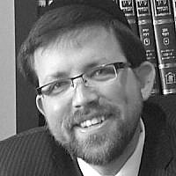

As Jews in Israel and America brace for Passover during the worst pandemic in a century, everyone should use an abundance of caution when preparing and observing the holiday.

So how will this Passover be different than all the Passovers?

For before every Passover we huddle in large grocery stores and crowed the aisles with so many others, this Passover we will order everything online (and it’s just as good).

For before every Passover, we take our new dishes to the Dishes Mikvah, this Passover we will gift them to a non-Jew and use them for less than 30 days as is permitted.

For before every Passover, we may sell our Chametz in person, this Passover, we will sell it online or over the phone.

For before every Passover we call family and loved ones before the holiday, this Passover we will also call our neighbor, the elderly, or a forgotten friend to check on them and see that they are okay.

For on every Passover, many eat handmade Matzah on Sader night, this year if we feel it is unsafe, we will rely on most rabbis who rule that machine matzah is just as good or even better.

For before every Passover, many people don’t sell actual Chametz, this Passover we will continue, but ask our rabbi what exactly is included or not included under that category. You’ll be surprised. Additionally, [some rabbis in Israel](https://www.kipa.co.il/%D7%99%D7%94%D7%93%D7%95%D7%AA/956548-%D7%94%D7%A8%D7%91-%D7%9C%D7%91%D7%A0%D7%95%D7%9F-%D7%9C%D7%97%D7%95%D7%A9%D7%A9%D7%99%D7%9D-%D7%9E%D7%95%D7%AA%D7%A8-%D7%94%D7%A9%D7%A0%D7%94-%D7%9C%D7%A7%D7%A0%D7%95%D7%AA-%D7%97%D7%9E%D7%A5-%D7%95%D7%9C%D7%9E%D7%9B%D7%95%D7%A8-%D7%90%D7%95%D7%AA%D7%95-%D7%91%D7%9E%D7%9B%D7%99%D7%A8%D7%AA-%D7%97/) have already instructed that those who don’t usually sell actual Chametz on Passover and are concerned they may run out of food this year, may sell actual Chametz.

For before every Passover, we burn our Chametz in large gatherings adhering to fire safety rules, this Passover we will be adhering both to fire safety rules and avoiding large groups.

For during every Passover, we gather with family and friends in large beautiful Seder, this Passover we will have an intimate, beautiful, and small Seder.

For before every Passover, we may be in an airport, train station, or other forms of mass transportation, this Passover we will stay local.

For before every Passover, we don’t need to think of those who are in quarantine, this Passover we are obliged to think of and care for those who are in quarantine, keeping everyone safe.

For every Passover, we dip our food twice, this Passover we will also dip, just with our own personal dish. No sharing.

For on every Passover, we have only one U’rchatz and one Rachtzah, on this Passover, we will Purell our hands before every time we eat anything with our hands.

For on every Passover, we dry our hands with a regular towel, on this Passover we will use disposable paper towels.

For on every Passover we sit reclining, this Passover we will also recline, just with more of a distance between every person.

For on every Passover, we think about the soldiers and members of the security forces who put their lives on the line so we can be safe, this Passover we will think of all the doctors and healthcare workers who are putting their lives on the line, working in overnight shifts, to make sure they save as many lives as possible.

For on every Passover, we go to synagogue and pray with so many others, on this Passover we will keep everyone safe by staying and praying at home.

For on every Passover we see our in-laws, this time we will tell them after the holiday how it went.

For on every Passover, we say “*Le’Shana Haba’ah Birushalayim Habenuya*”, next year in the rebuilt Jerusalem.

This Passover we will add *Le’Shana Haba’ah Birushalayim Habri’ah”*, next year in the healthy Jerusalem.

Wishing everyone a happy and healthy Passover! Pesach Kasher Ve’Same’ach!

Rabbi Elchanan Poupko is a rabbi, writer, teacher, and blogger (www.rabbipoupko.com). He lives with his wife in New York City and is the president of EITAN - The American-Israeli Jewish Network

*Reprinted from the March 17, 2020 email of Arutz Sheva.*

**Rabbi Berel Wein**

**On Parashas Vayikra**

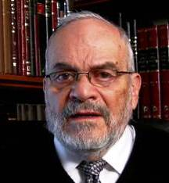

In this week's Torah reading, the Torah describes for us the rituals of offering sacrifices in the temple. Our generation and our society are far removed from the concept of animal sacrifices and, because of this, the Torah reading somehow does not really speak directly to us.

Already in the 13th century, Rabbi Moshe ben Maimon offered the idea that we have to view sacrifices for the value that they entail and not so much for the rituals themselves Even though one of the six sections of the Mishnah and the Talmud concerns itself almost exclusively with the laws and rituals of animal sacrifices, this has become more of a theoretical and scholarly exercise, without it having any practical effect upon our lives.

When the temple will be rebuilt, then all these things will become actualized once more, but for now they are theoretical. Rabbi Moshe ben Maimon, said that the idea of sacrifice was that the person offering the sacrifice should see his own self as being the sacrifice.

This means that one must sacrifice one's desires, habits, lifestyle and all sorts of other pleasures to the service of G-d and of Israel. This type of sacrifice certainly remains alive and necessary today as well, and it entails the ability to give away what we think is ours for a cause that we believe to be greater and nobler than our own personal needs and wants.

Because of this, the concept of sacrifices has cogency and meaning for each one of us. If we look at our lives, we see that every day we make choices in which ultimately lie the sacrifice of oneself, one's interests, and one's own desires, for a higher cause.

There are many different types of sacrifices listed in this week's Torah reading. There is a sacrifice that is a complete donation to G-d where the man or woman bringing the sacrifice really has no immediate or material benefit. This altruism was reserved usually for public sacrifices that were offered twice a day in the temple.

There are sacrifices, however, that are very personal. There are sacrifices that are meant to atone for sins and only we know which sins we have committed. There are sacrifices for wrongdoing when we are not even certain if the wrongdoing occurred. Because of this, we are constantly involved in reassessing our lives and rethinking events and policies that we have subscribed to.

People change during their lifetime and hopefully they mature and see things in a different light. The idea of sacrifice for sins passed makes for a stronger present and a brighter future. There are also sacrifices of thanksgiving. That is a sacrifice of one's own ego. In this instance we have to acknowledge that we found ourselves in terrible difficulty, in great danger and we survived and emerged from the crisis….with help. We must admit that we did not do it on our own.

We are thankful to others and we are thankful to our Creator for having allowed us to be able to survive the issue, that is a sacrifice of ego. No one wants to admit that we need help from others. We all desire to be self-sufficient in the broadest sense of the word. But life teaches us that none of us are completely self-sufficient, that all of us are dependent upon others.

Then there are sacrifices that mark our holidays that are, so to speak, ritual sacrifices imposed upon us by history. The sacrifice of the paschal lamb is the outstanding example of this. We cannot proceed with the future unless we are aware of the past and are aware of the sacrifices of the past that enable us to even contemplate a future, a better future.

All these ideas are encompassed in the ritual laws of the sacrifices introduced in this week's Torah reading. The Torah reading begins by G-d calling out to Moshe. The same word in Hebrew that represents calling out also represents glory and honor. Because of that, when we hear G-d calling out to us, governing our behavior and thoughts, then we are aware of the glory and honor of being part of the people of IsraelEveryone should stay healthy and cheerful. I look forward to seeing you soon.

*Reprinted from this week’s website of Rabbiwein.com*

**Kosher Restaurants Feeling the**

**Pinch as Coronavirus Pandemic**

**Closes Bars, Eateries Across City**

**By Ben Cohen**



New York City’s vibrant kosher restaurant scene was reeling on Monday as bars and eateries across the city shuttered in anticipation of a worsening coronavirus pandemic.

The collective decision on Sunday by the governors of New York, New Jersey and Connecticut to close all bars and restaurants, excepting takeout and delivery, from 8 p.m. on Monday night was a potentially devastating blow to an industry that has already seen revenues slump amid public concern over the spread of COVID-19.

“There is still so much that is unknown, but there’s no question that we’ve experienced a massive drop in business over the last week,” Sruli Eidelman — who runs the popular kosher southern BBQ joint Izzy’s Smokehouse in Brooklyn — told The Algemeiner on Monday.

One of the world’s major eating capitals, New York’s bars and restaurants employ up to 320,000 workers, the majority of whom are now facing an indefinite period of unemployment.

“We’re preparing for the worst,” Eidelman stated.

Although his restaurant will remain open for takeout and delivery orders, Eidelman said that he was facing a 25-percent reduction in staff.

“We’re hoping this thing passes really quick,” he added.

Zalman Wuensch — owner of the upscale Wolf and Lamb kosher steakhouse in midtown Manhattan — expressed similar anxiety about the impact on restaurant staff.

“The servers are in a very tight position, there’s no work for them, and we’re operating with a skeleton staff in the kitchen,” Wuensch told The Algemeiner.

While Wuensch is also keeping his establishment open for takeout and delivery orders, he noted that many Wolf and Lamb patrons do not live near the restaurant’s East 48th street location. He hoped demand would be greater at the restaurant’s second location in Brooklyn’s Flatbush section.

“It’s a day-to-day situation,” Wuensch said. “We’re really just watching and trying our best.”

A survey of New York’s hospitality sector by Crain’s New York Business in 2016 found that there were nearly 300 kosher restaurants in the city — almost as many as the number of French and Indian eateries — bolstered by a growing trend toward keeping kosher among younger Jews.

But all restaurants in the city would be feeling the pinch in the current crisis, according to Doris Schechter — founder of the normally-packed kosher eatery My Most Favorite Food on Manhattan’s Upper West Side.

“We’re all in the same boat, there’s no differentiation between kosher and non-kosher,” Schechter told The Algemeiner. “We’re all in disbelief.”

Nonetheless, Schechter sounded an optimistic note when asked about her restaurant’s prospects during the coming weeks of uncertainty.

“We’re all hanging in, we’re living in crazy times,” she said. “But we’re here for orders to go. And we’re getting ready for Passover.”

*Reprinted from the March 17, 2020 website of Matzav.com. Originally printed in The Algemeiner.*

Pesach at Risk

By LarryGordon

[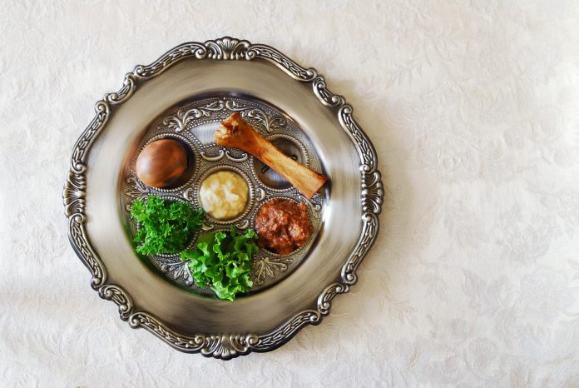](http://d16cunm4ue8a76.cloudfront.net/wp-content/uploads/2020/03/seder-plate-iStock-139574475.jpg)Traditional symbols on a seder plate for the Jewish festival of Passover.

It is three weeks away, and Pesach as many once knew it might be at risk. This year seemed to be featuring a greater and more diverse panorama of Pesach programs around the globe, but that is coming to a complete halt. If there was ever an endeavor or business that had the rug pulled out from under it, so to speak, by forces beyond anyone’s control, this is it.

It’s like some of those rather amateur magic tricks: now you see it, now you don’t.

While we have addressed this subject many times — particularly at this time of year — let’s not be presumptuous. Though it may seem like many, only a minority of people pack up, pick up, and go somewhere hundreds or even thousands of miles away for Pesach.

Right now, it looks like most of us will be observing and enjoying the chag this year with our families exactly where we are now sitting and reading this article — or maybe over in the next room, a little closer to the pantry.

For the thousands of families who were planning on spending Pesach in Israel or Italy or perhaps parts of Florida or more exotic locales like Cancun and Panama, it is likely that those plans have changed and many, if not most, will be home for what will be, G-d willing, a good old-fashioned yom tov. And that does not sound too bad at all.

OK, so you want to know about the money, as most of these hotel programs require full advance payment with your reservation. While the situation is still evolving, the story at this point is that while many program administrators are refunding a majority of the money, unfortunately others have told some customers we’ve spoken to that they just cannot and there is nothing anyone can do about that.

One estimate is that the hotel industry for Pesach alone is about $100 million. There are big losses piling up here on both sides of the equation. Most entrepreneurs are trying to do the right thing and return as much money to clients as possible. An offer I saw from one hotel group was to refund about 35% of the money, with the balance being credited to next year’s program, G-d willing, long after this is all over with.

The halachic question that will most likely be dealt with down the road — probably after yom tov — is whether or not the customers have any financial liability if, for whatever reason, the Pesach program does not happen.

If the assumption is that families who choose to spend Pesach away at this or that Hilton or Sheraton can most likely absorb the loss, that is not accurate and is certainly unfair. Almost anyone in business will agree that if you cannot deliver the product you sold, then the client is certainly entitled to a full refund.

A person who was planning on going to a hotel in New Jersey asked, “But what if the program directors cannot afford to pay back in full the money they collected from people?”

I took the liberty of calling the general manager’s office of one of the New York area hotels to ask if they were refunding the money paid to them by the operators of the Pesach program.

The person who answered the phone at this particular Hilton said to me that she was not at liberty to discuss the matter and that I should be speaking to the program hosts. I told her that I would do that if it were relevant to me, but that was not my motive here. I reiterated that I just wanted to know if, considering the lack of liability here on anyone’s end and considering that there was a worldwide pandemic taking place, they would do the right thing and make people whole under the circumstances.

“I’m not at liberty to discuss that,” she said. I told her that I think I hear what she is saying loud and clear.

So while at this point I’m not sure what is going to happen. It is beginning to sound like this is the stuff that drawn-out negotiations and lawsuits are made of, though I hope that will not be the case.

I believe that if the federal government can shut down most of the country and legislate people’s movements, they should also be able to direct these hotels in the United States to painlessly make these Pesach program operators whole so that they can refund the monies paid to their customers.

It is unlikely that anything like that will happen, but when all this shakes out one of these days, after this crisis is under control or hopefully behind us, it is something that should be looked into.

So, no, Pesach itself is not at risk, but what we really need for the arrival of the chag in three weeks is a miracle of sorts that has this virus leaving us as quickly as it arrived so that, if nothing else, we will at least be able to go to shul on yom tov.

This is an unprecedented event we are living through. It is as historic as it is nerve-racking. One of the major issues in our communities is that we too often feel that matters like this somehow do not apply to us. A lesson of this ongoing crisis is that at the end of the day, we are flesh-and-blood humans just like everyone else.

The lessons we are being asked to internalize from this experience are numerous. Hopefully we will shortly be able to look back and analyze what took place here and how it might have effectively changed many of us. Perhaps we should start doing that today.

*Reprintsed from the March 20, 2020 email of the Five Towns Jewish Times.*

1. His father was Reb Eliezer Shimon Kazarnovsky, a grandson of Rebbetzin Menucha Rochel Slonim, making him the Rebbe Rashab’s second cousin once removed. When he became the Rov in Uzbekistan (as will be related below), following their tradition of using one’s father’s name as a surname, he changed his name to Eliezerov (which means “the son of Eliezer”).
2. See *Igros Kodesh*, vol. 1, p. 164.
3. In cases of disagreement between the *Beis Yosef* (HaRav Yosef Caro, author of the *Shulchan Aruch*) and the *Rema* (HaRav Moshe Isserles), Ashkenazim generally follow the *Rema* and Sephardim generally follow the *Beis Yosef*. Since he would be serving the needs of a Sephardic community, he was instructed to follow the rulings of the *Beis Yosef*, although he himself was an Ashkenazi.
4. He is most famous for his works *Ketzos ha-Shulchan*, *Piskei HaSiddur*, *Shi'urei Mikveh*, and *Shi'urei Torah* (Measurements of the Torah), in which he converted [biblical](https://en.wikipedia.org/wiki/Biblical) [measurements](https://en.wikipedia.org/wiki/Measurement) into contemporary measurements. 
5. One of Georgia’s main cities is Kutaisi, which is around 600 miles from Rostov.
6. They were dressed in the garments of their country, and originally, when they came to speak with the Rebbe, the chassidim were afraid that they were Cossacks.
7. They spoke in Russian and the Rebbe responded in Yiddish. His son, HaRav Yosef Yitzchok, served as the interpreter.
8. *Igros Kodesh*, vol. 5, p. 59.
9. See above,
10. While the Rebbe had sent his cousin Reb Shlomo Yehuda Leib to Buchara, in the eyes of many there was a difference. There, the community originally asked him to stay for three years, and the Rebbe encouraged and instructed him to stay for longer. Here, by contrast, the Rebbe was sending someone the community did not know and had never seen, and they were fearful that the differences between Ashkenaz and Sephard might clash.
11. It should be noted that another Ashkenazi Rov, a *talmid* of Reb Chaim Brisker, as Rov of Kutaisi for many years before Reb Shmuel’s arrival. However, that Rov was now quite old, and he didn’t have the energy to go from *shul* to *shul* and community to community to offer rabbinical services, as Reb Shmuel did~~.~~